NAME: MOHAMMAD MAKKI

TOPIC: IR NEC PROTOCOL TRANSMISSON

Contents

Aim 3

Components 3

Pinout and Circuit diagrams 3

Tables and Waveforms 4

NEC Infrared Transmission Protocol 6

Assembly Code 7

Flow Chart 9

Figure 1 7805 Voltage Regulator IC pin out 3

Figure 2 PIC16F877A pin diagram 3

Figure 3 PIC circuit schema 3

Figure 4 Resistor’s color code 3

Figure 5 IR circuit schema Figure 6 IR receiver sensor pin out 4

Figure 7 IR signal of initial message 4

Figure 8 IR signal of NEC protocol 4

Figure 9 Register file map 4

Figure 10 INTCON register datasheet 5

Figure 11 Option register datasheet 5

# Aim

Intercept the IR signals sent by a remote using NEC protocol and preview them in binary on led lights.

# Components

* Pic16f877a
* Voltage regulator
* 9v DC battery power supply
* Led lights
* 271 ohm resistors
* 220 ohm resistors
* Diode
* 4 MHZ crystal
* 104 pF capacitor
* 100 yF capacitor
* 224 pF capacitor
* IR Infrared 38KHz Shielded Receiver 3-pin VS1838B
* Remote controller using NEC protocol

# Pinout and Circuit diagrams

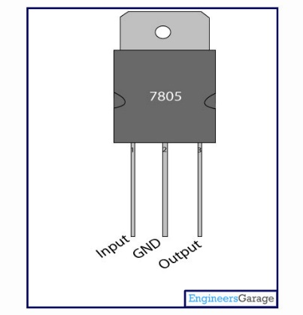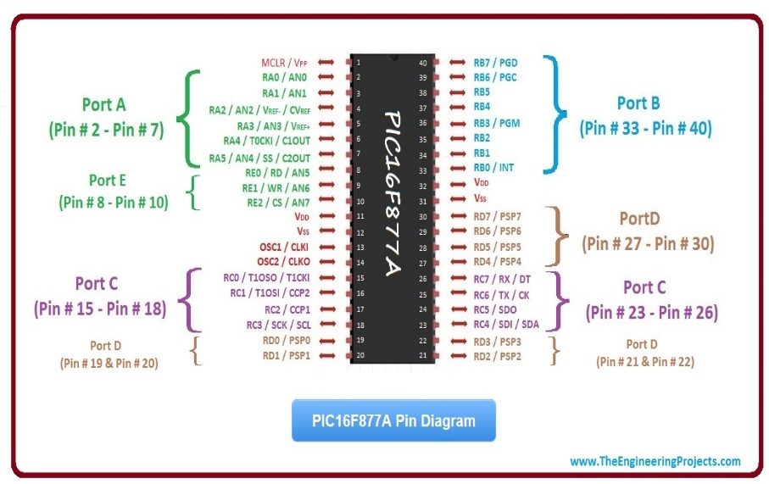

Figure 1 7805 Voltage Regulator IC pin out

Figure 2 PIC16F877A pin diagram

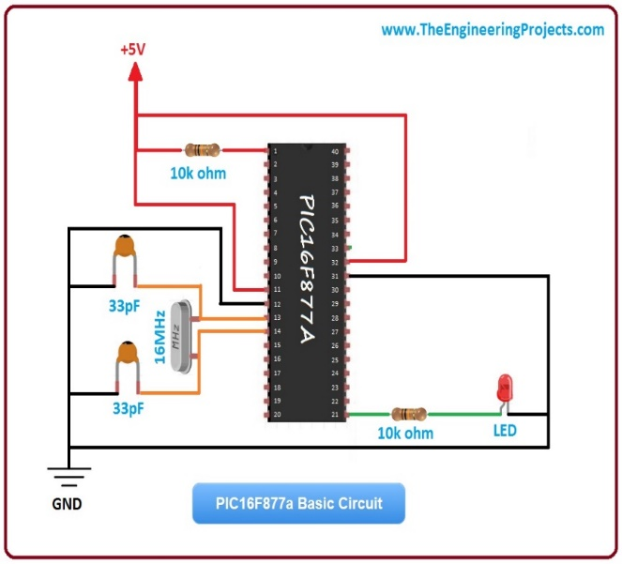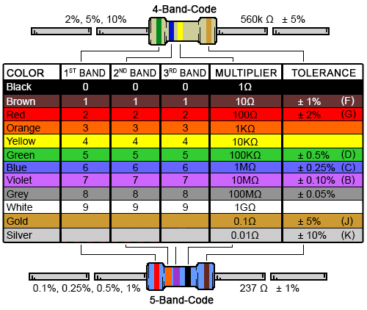

Figure 3 PIC circuit schema

Figure 4 Resistor’s color code

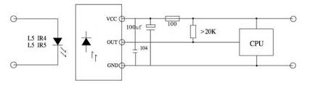 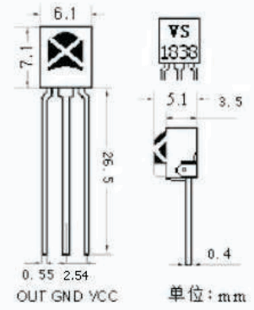

Figure 5 IR circuit schema Figure 6 IR receiver sensor pin out

# Tables and Waveforms

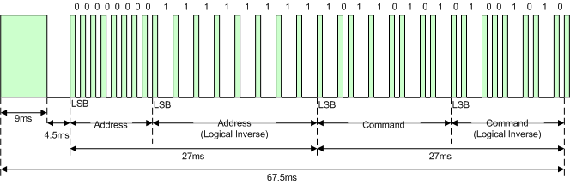

Figure 7 IR signal of initial message

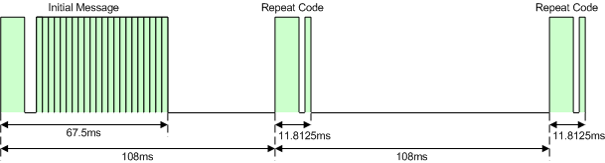

Figure 8 IR signal of NEC protocol

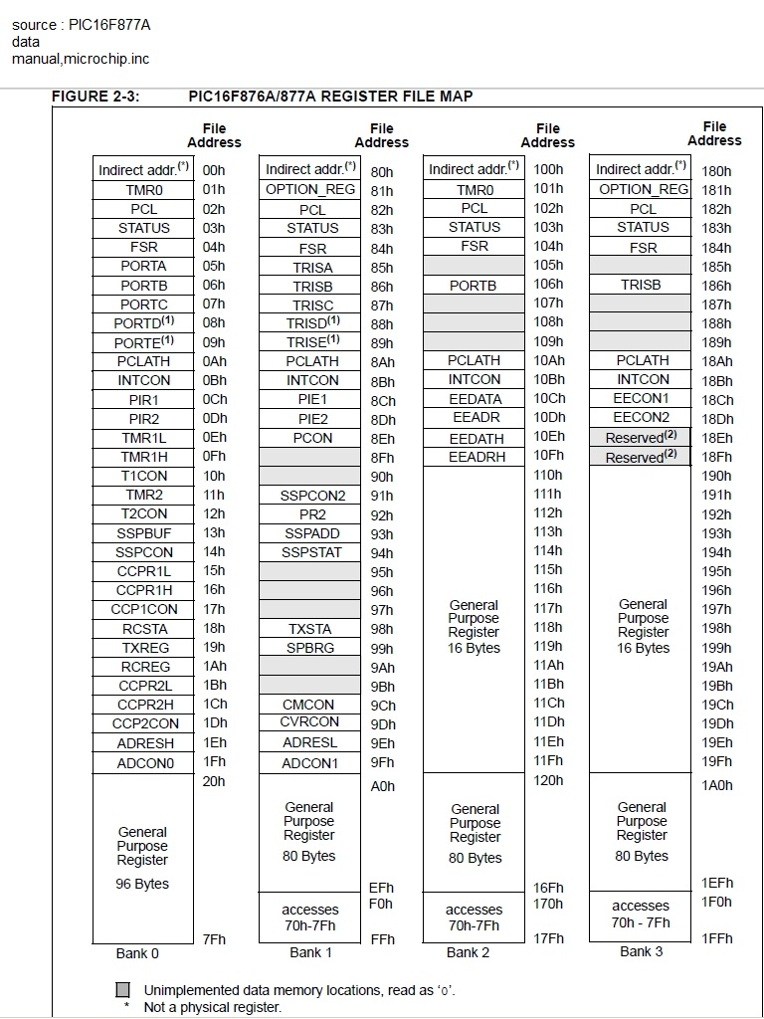

Figure 9 Register file map

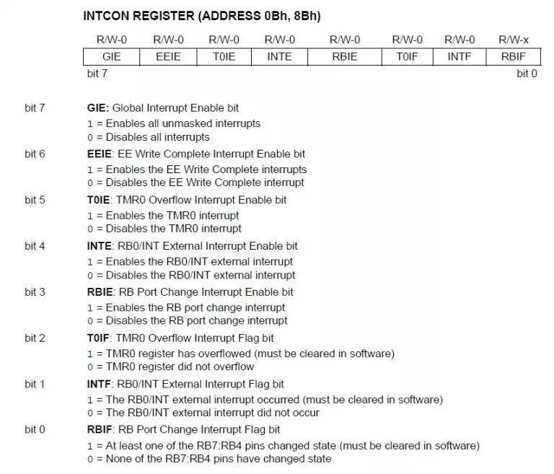

Figure 10 INTCON register datasheet

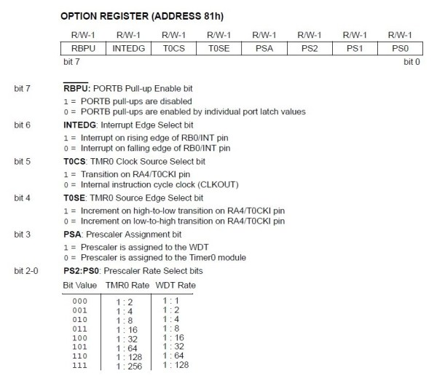

Figure 11 Option register datasheet

# NEC Infrared Transmission Protocol

The NEC IR transmission protocol uses pulse distance encoding of the message bits. Each pulse burst (mark – RC transmitter ON) is 562.5µs in length, at a carrier frequency of 38kHz (26.3µs). Logical bits are transmitted as follows:

* Logical '0' – a 562.5µs pulse burst followed by a 562.5µs space, with a total transmit time of 1.125ms
* Logical '1' – a 562.5µs pulse burst followed by a 1.6875ms space, with a total transmit time of 2.25ms

When transmitting or receiving remote control codes using the NEC IR transmission protocol, the WB_IRRC performs optimally when the carrier frequency (used for modulation/demodulation) is set to 38.222kHz.

When a key is pressed on the remote controller, the message transmitted consists of the following, in order:

* a 9ms leading pulse burst (16 times the pulse burst length used for a logical data bit)
* a 4.5ms space
* the 8-bit address for the receiving device
* the 8-bit logical inverse of the address
* the 8-bit command
* the 8-bit logical inverse of the command
* a final 562.5µs pulse burst to signify the end of message transmission.

The four bytes of data bits are each sent least significant bit first.

It takes 27ms to transmit both the 16 bits for the address (address + inverse) and the 16 bits for the command (command + inverse). This comes from each of the 16-bit blocks ultimately containing eight '0's and eight '1's - giving (8 * 1.125ms) + (8 * 2.25ms). 67.5ms to fully transmit the message frame (discounting the final 562.5µs pulse burst that signifies the end of message).

If the key on the remote controller is kept depressed, a repeat code will be issued, typically around 40ms after the pulse burst that signified the end of the message. A repeat code will continue to be sent out at 108ms intervals, until the key is finally released. The repeat code consists of the following, in order:

* a 9ms leading pulse burst
* a 2.25ms space
* a 562.5µs pulse burst to mark the end of the space (and hence end of the transmitted repeat code).

# Assembly Code

#INCLUDE "P16F877A.INC"

__CONFIG _CP_OFF & _WDT_OFF & _PWRTE_OFF & _BODEN_OFF & _LVP_OFF & _HS_OSC

CHECK EQU 0X20

COUNTERB EQU 0X21

CONTROL EQU 0X22

IMCOUNTER EQU 0X23

RECIEVED EQU 0X24

ADDRESS EQU 0X25

ANTIADDRESS EQU 0X26

COMMAND EQU 0X27

ANTICOMMAND EQU 0X28

RES_VECT CODE 0x00 ; processor reset vector

GOTO CONFI ; go to beginning of program

INT_VECT CODE 0X04 ; interrupt vector

GOTO ISR ; go to interrupt service routine

ISEQUAL MACRO CHECK,THING

MOVF THING,W

SUBLW CHECK

BTFSS STATUS,Z

BCF CONTROL,1 ;YA3NE NOT EQUAL SO FALSE BOOL

BTFSC STATUS,Z

BSF CONTROL,1 ;YA3NE EQUAL SO TRUE BOOL

ENDM

CONFI BSF STATUS,RP0

CLRF TRISB

BSF TRISB,0 ;PORT B OUTPUT EXCEPT FIRST BIT

CLRF TRISD ;PORT D OUTPUT

CLRF OPTION_REG

BSF OPTION_REG,6 ; INTERRUPT ON RISING EDGE

MOVLW H'90' ;GIE ENABLED // TMR0IE DISABLED //INTE ENABLED

MOVWF INTCON

BCF STATUS,RP0

MOVLW H'FF'

MOVWF PORTD

CLRF COUNTERB

CLRF CONTROL

CLRF IMCOUNTER

CLRF RECIEVED

CLRF CHECK

GOTO MAIN

ISR BCF INTCON,GIE ;DISABLES ALL INTERRUPTS

BTFSC INTCON,INTF ;IF SIGNAL INTERRUPT

GOTO SIGNALINT

INCF COUNTERB,F ;ELSE TIME INTERRUPT

ISEQUAL D'30',COUNTERB ;IGNORE ACTIVATED AT LIMIT

BTFSC CONTROL,1

BCF INTCON,TMR0IE ;DISABLES TIMER INTERRUPT

BTFSC CONTROL,1

CLRF COUNTERB ;CLEARS COUNTERB

BCF INTCON,TMR0IF ;CLEARS TIMER INTERRUPT FLAG

RETFIE

SIGNALINT BSF INTCON,TMR0IE ;ENABLES TIMER INTERRUPT FLAG BECAUSE IT IS INTIALLY DISABLED

BTFSC CONTROL,0 ;BIT ZERO OF CONTROL IS INITIAL MESSAGE

GOTO IMR

ISEQUAL D'26',COUNTERB ;CHECK FOR START PULSE

BTFSC CONTROL,1

BSF CONTROL,0 ;ACTIVATE INITIAL MESSAGE ROUTINE

RANDEVU CLRF COUNTERB ;CLEARS COUNTERB

BCF INTCON,TMR0IF ;CLEARS TIMER INTERRUPT FLAG

BCF INTCON,INTF ;CLEARS SIGNAL INTERRUPT FLAG

CLRF TMR0 ;CLEARS TIMER TMR0

RETFIE

IMR INCF IMCOUNTER,F

ISEQUAL D'2',COUNTERB ;CHECK IF IT IS LOGIC ZERO

BTFSC CONTROL,1

BCF RECIEVED,0 ;IF TRUE LOGIC ZERO

BTFSS CONTROL,1

BSF RECIEVED,0 ;IF FALSE LOGIC ONE

ISEQUAL D'8',IMCOUNTER

BTFSS CONTROL,1 ;SKIP IF TRUE

GOTO CIAA

MOVF RECIEVED,W

MOVWF ADDRESS

CLRF RECIEVED

GOTO RANDEVU

CIAA ISEQUAL D'16',IMCOUNTER

BTFSS CONTROL,1 ;SKIP IF TRUE

GOTO CIC

MOVF RECIEVED,W

MOVWF ANTIADDRESS

CLRF RECIEVED

GOTO RANDEVU

CIC ISEQUAL D'24',IMCOUNTER

BTFSS CONTROL,1 ;SKIP IF TRUE

GOTO CIAC

MOVF RECIEVED,W

MOVWF COMMAND

CLRF RECIEVED

GOTO RANDEVU

CIAC ISEQUAL D'32',IMCOUNTER

BTFSS CONTROL,1 ;SKIP IF TRUE

GOTO DONE

MOVF RECIEVED,W

MOVWF ANTICOMMAND

CLRF RECIEVED

GOTO ENDIMR

DONE RLF RECIEVED,F

GOTO RANDEVU

ENDIMR BCF CONTROL,0 ;CLEAR IMR BIT

CLRF IMCOUNTER ;CLEAR IMCOUNTER

GOTO RANDEVU

MAIN MOVF COMMAND,W

MOVWF PORTD

GOTO MAIN

END

# Flow Chart